**MARKET BASKET INSIGHTS 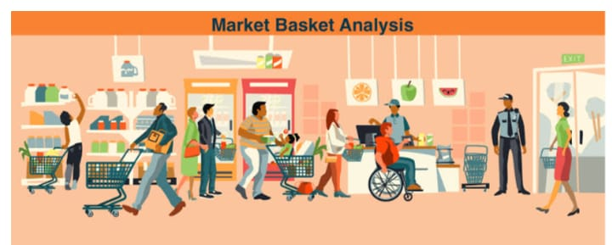Problem Statement:**

**In the dynamic landscape of modern retail, understanding customer behavior and optimizing product offerings are critical for enhancing revenue, customer satisfaction, and operational efficiency. Our organization seeks to leverage Market Basket Analysis (MBA) to gain actionable insights from transaction data. The primary goal is to uncover hidden patterns, associations, and relationships among purchased items, ultimately leading to strategic decisions that will benefit our business.**

**Understanding:**

**Market basket insights is a data science technique that analyzes customer purchase history to identify patterns and relationships between products. This information can be used by businesses to improve their marketing, merchandising, and product development strategies.**

**One of the most common ways to use market basket insights is to identify product affinities. Product affinities are relationships between products that are frequently purchased together. For example, a business might find that customers who purchase diapers are also likely to purchase baby wipes and formula. Once these affinities are identified, businesses can use them to improve their store layout, product placement, and cross-selling and upselling strategies.**

**Design Thinking:**

**In this phase, we will apply the principles of Design Thinking to solve the problem at hand. Design Thinking is an iterative process that focuses on understanding the needs of stakeholders and creating user-centered solutions. Here are the steps we will follow:**

**1.Empathize** **with customer:**

Understand customer needs, wants, and pain points by analyzing their purchase history and conducting customer interviews.

**2.Define:**

Identify the specific problem that you are trying to solve with market basket insights. For example, you might be trying to improve store layout, product placement, or cross-selling and upselling opportunities.

**3.ideate:**

Generate a variety of solutions to the problem that you identified. Do not be afraid to think outside the box.

**4.Prototype:**

Create a prototype of your solution and test it with a small group of customers. This will help you to identify any potential problems and make necessary adjustments.

**5.Test:**

The grocery store tests the new store layout with a small group of customers. The customers provide feedback on the layout and suggest ways to improve it.

**6.Iterate:**

Gather customer feedback. Businesses can collect customer feedback through surveys, interviews, and focus groups. This feedback can be used to identify areas where the solution can be improved.

**7.Implement:**

The grocery store implements the new store layout and monitors the results. The store finds that the new layout is more efficient and that customers are purchasing more products.

**8.Communication:**

The grocery store communicates the results of the market basket insights design thinking process to stakeholders. The store shows how the new store layout has improved the customer experience and increased sales.

By following this Design Thinking approach, businesses can develop innovative and effective solutions to their problems. By iterating on their solutions and communicating their results to stakeholders, businesses can ensure that their solutions are both customer-friendly and profitable.